C/C++ FALAFEL LAB REPORT
Sample program execution. The output of your program should look similar to this, not what is on the PowerPoint or video discussions.
1) Enter your name, student ID, platform (Mac or PC) and date
Name and Student ID: Jay Gupta, Student ID: 0961979
Class: CIS054 C/C++ Programming
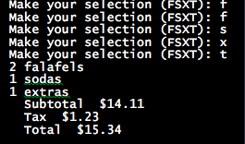
Platform (Mac or PC): PC
Date: 3/7/2020

DESCRIPTION:
A falafel is a very popular Middle Eastern food. It is served as a sandwich
stuffed in pita bread usually containing lettuce, tomatoes and some
round balls of fried chickpeas. The fried balls of chickpeas look like
meatballs but are green on the inside and are very nutritious.

Modify the Falafel program to do the following:
1) Use separate integers as counters for each type of item sold (Falafels, Sodas, Extras). ✔
2) Use a constant (const in C++, or #define in C) to define the tax rate. ✔
3) When the 'T' key is pressed for the total, display the count and name for each item, the subtotal for all items, compute tax at 8.7%, display the amount of tax, and the final total for all items plus the tax. ✔
4) Each display must show two digits past the decimal point for the subtotal, tax and total. ✔
5) Include in the test showing the display when no items are selected when 'T' is entered. ✔
6) The program must process unexpected or illegal inputs. If the user enters a menu selection that is invalid, an error message must be displayed. ✔
LAB REPORT:
2) Determine the Inputs, Processing and Outputs before creating the program
INPUTS | PROCESSING | OUTPUTS
- ‘f’ for falafels  - ‘s’ for sodas  - ‘x’ for extras  - ‘t’ for total | - Display the menu.  - Ask user to select one of the four options, and use input validation.  - When user asks for a specific food, add one to its counter.  - When user is done, he/she enters ‘T’ for total.  - Display what the user ordered.  - Finally, display the subtotal, tax, and total. | - Quantity of each food item  - Subtotal, tax, and total

`
3) Fill in the EXPECTED & ACTUAL RESULTS
TEST DATA VALUES  Provide several examples of menu selections. Also test no selections when 'T' is entered. | EXPECTED RESULT  Computed values before the program is run | ACTUAL RESULT  Fill in the output displayed  by the program
1) 3 falafels, 7 sodas, 4 extras  2) 20 falafels, 10 sodas, 5 extras  3) 10 falafels, 20 sodas, 16 extras  4) 0 falafels, 0 sodas, 0 extras | 1)  The subtotal is: $37.41  The tax is: $3.25  The total is: $40.66  2)  The subtotal is: $133.25  The tax is: $11.59  The total is: $144.84  3)  The subtotal is: $121.42  The tax is: $10.56  The total is: $131.98  4)  The subtotal is: $0.00  The tax is: $0.00  The total is: $0.00 | 1)  The subtotal is: $37.41  The tax is: $3.25  The total is: $40.66  2)  The subtotal is: $133.25  The tax is: $11.59  The total is: $144.84  3)  The subtotal is: $121.42  The tax is: $10.56  The total is: $131.98  4)  The subtotal is: $0.00  The tax is: $0.00  The total is: $0.00

DISCUSSION:
4) Complete the DISCUSSION section. It does not need to be long, but it needs to be complete.
4a) What did you do to develop the program? ("Followed the Directions" is not a complete description)

First, I figured out what the output will look like. I configured the menu, and decided to return a character each time ‘displayMenu()’ was called. From there, I decided to use an if/else if loop nested in a do-while to capture the user’s input until they typed in ‘T’ for total.
I wanted the output to look good, with no grammar mistakes, and to have spacing to make it easy to read, and possibly debug. I thought about creating separate methods to calculate costs and display them, but in the end, decided it was much simpler and cleaner to do it all in main.
When all was said and done, I tested the program multiple times to make sure it was accurate and handled errors appropriately.

4b) What problems did you have and how did you overcome the problems?

I had a problem in the beginning with the output. It was giving exponential numbers, because the program wanted me to initialize each food to ‘0’. I think because it was just being declared, it gave a very large number, and that, in turn, caused the subtotal, tax, and total to be large as well.
Overall, this project, compared to the previous ones, was just a matter of simple logic, and making sure things ran smoothly.

PROGRAM OUTPUT:
5) Show screen shots for at least TWO sample purchases of the program execution. You MUST also provide a screenshot showing what happens when the 'T' key is pressed.
Refer to previous lab assignments for instructions on how to capture a screen or portions of a screen for either the PC or a Mac. Provide a screenshot into the lab report showing several items purchased. Provide another screenshot showing the result of an unexpected or illegal input.

1)
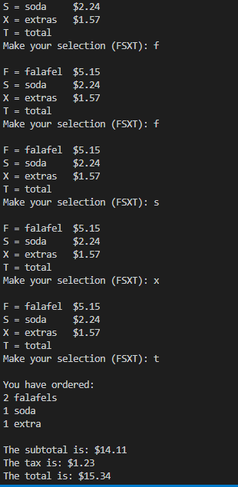

2)
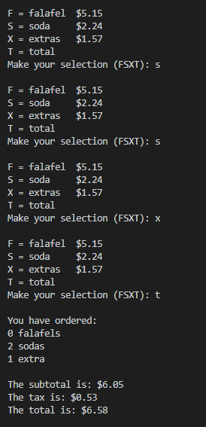

3)
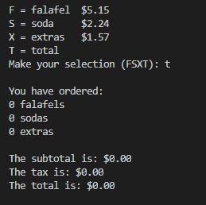

PROGRAM LISTING:
6) Copy and paste the code that YOU typed to make the program work. Your program should include a comment block at the top that shows the name of the program, date, version and your name.
/**
* Name: Jay Gupta
* StudentID: 0961979
* Date: 3/7/2020
* Program Name: falafel.cpp (V1.0)
* CIS054 C/C++ Programming
*
* Functionality: Given the quantity of each food item, displays the various costs.
* Inputs: 'f' for falafels, 's' for sodas, 'x' for extras, 't' for total
* Output: Quantity of each food item, subtotal, tax, total
*/

#include <iostream> // cin and cout
#include <cctype> // toupper
#include <iomanip> // to set decimal places
using namespace std;

char displayMenu();

// global variables
char selection;

// constants
const double TAX_RATE = 0.087;

int main() {
double subtotal, tax, total;
double price;

int falafels = 0;
int sodas = 0;
int extras = 0;

do {
selection = displayMenu();
if (selection == 'F') {
falafels +=1;
} else if (selection == 'S') {
sodas += 1;
} else if (selection == 'X') {
extras += 1;
}
} while (selection != 'T');

// Display user's order
cout << endl;
cout << "You have ordered: " << endl;

// handle plurals
if (falafels == 1) {
cout << falafels << " falafel" << endl;
} else {
cout << falafels << " falafels" << endl;
}

if (sodas == 1) {
cout << sodas << " soda" << endl;
} else {
cout << sodas << " sodas" << endl;
}

if (extras == 1) {
cout << extras << " extra" << endl;
} else {
cout << extras << " extras" << endl;
}

// compute & display costs
subtotal = (falafels * 5.15) + (sodas * 2.24) + (extras * 1.57);
tax = TAX_RATE * subtotal;
total = subtotal + tax;

cout << fixed << setprecision(2);
cout << endl << "The subtotal is: $" << subtotal << endl;
cout << "The tax is: $" << tax << endl;
cout << "The total is: $" << total << endl << endl;

return 0;
}

char displayMenu() {
do {
cout << endl; // blank line before start of menu
cout << "F = falafel $5.15" << endl;
cout << "S = soda $2.24" << endl;
cout << "X = extras $1.57" << endl;
cout << "T = total" << endl;
cout << "Make your selection (FSXT): ";
cin >> selection;

selection = toupper(selection); // make selection uppercase

// error message
if (selection != 'F' && selection != 'S' && selection != 'X' && selection != 'T') {
cout << endl << "Incorrect Input. Please enter F, S, X, or T." << endl;
}
} while (selection != 'F' && selection != 'S' && selection != 'X' && selection != 'T');
return selection;
}

